ALPS RESILIENCE

PROGRESS REPORT · 2026
Muxara
Public Space
A recreational and social space for families and children, taking shape in the Muxara neighbourhood of Pemba City, Cabo Delgado.
PERIOD OF ACTIVITY  13 March 2026, in progress |  | LOCATION  Muxara neighbourhood, Pemba City, Cabo Delgado
DELIVERED BY  ALPS Constructions |  | IN PARTNERSHIP WITH  IOM Mozambique
FUNDED BY
The International Organization for Migration (IOM)

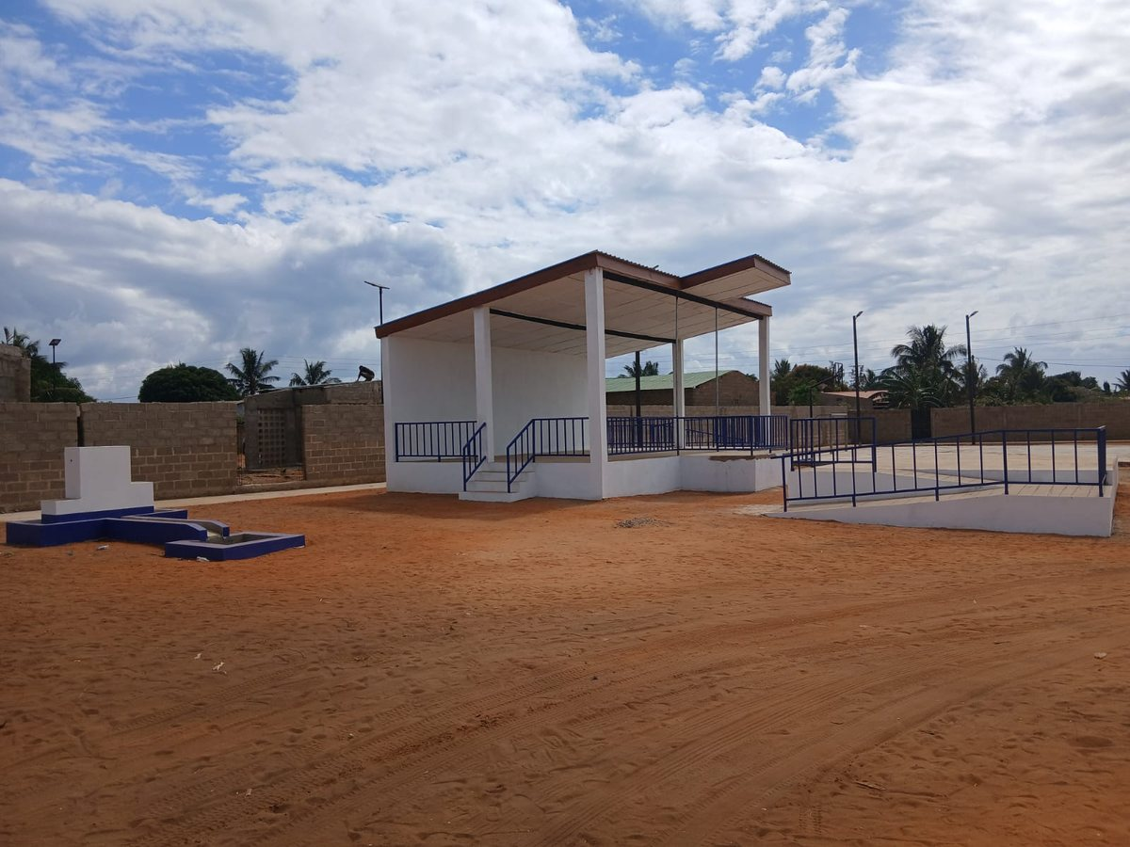
The Muxara public space taking shape, with the covered pavilion and the multi-use fields beyond.
OVERVIEW
A safe, shared place for a growing neighbourhood
ALPS Resilience, in partnership with the International Organization for Migration (IOM), is building a community public space in the Muxara neighbourhood of Pemba City. Muxara sits in the provincial capital, whose peri-urban neighbourhoods have grown quickly as families displaced by the conflict in northern Cabo Delgado have settled there. The space is being built as somewhere families can spend time together and children can play safely.
The design brings several uses onto one site: a covered pavilion for events and gatherings, shaded seating, multi-use fields, garden benches, and solar-powered lighting so the space can be used into the evening. Construction is at an advanced stage, with the structures built and finishing works underway.

MAIN OBJECTIVE
To give Muxara a safe, accessible and welcoming public space for recreation, play and social interaction, strengthening community ties and everyday life as the neighbourhood continues to grow.

WHAT’S BEING BUILT
Designed for play, rest and community life
The pavilion anchors the space. It is a roofed platform for community events, performances and meetings, reached by steps and a full-length accessible ramp with steel railings, so it is open to everyone, including older residents and people with reduced mobility.
Beside it, multi-use fields give young people room for organised sport, overlooked by shaded, tiered seating for spectators. Garden benches and planted areas create quieter places to sit. Solar-powered lighting keeps the whole space safe and usable after dark without adding a running cost for the community.
5
core elements on one site: covered pavilion, shaded seating, multi-use fields, garden benches and solar lighting.
At a glance
Covered pavilion  A roofed platform for events, performances and meetings. |  | Shaded seating  Tiered spectator stands beneath a steel canopy. |  | Multi-use fields  Open fields for football, basketball and community sport. |  | Solar lighting  Off-grid lighting for safe use after dark.

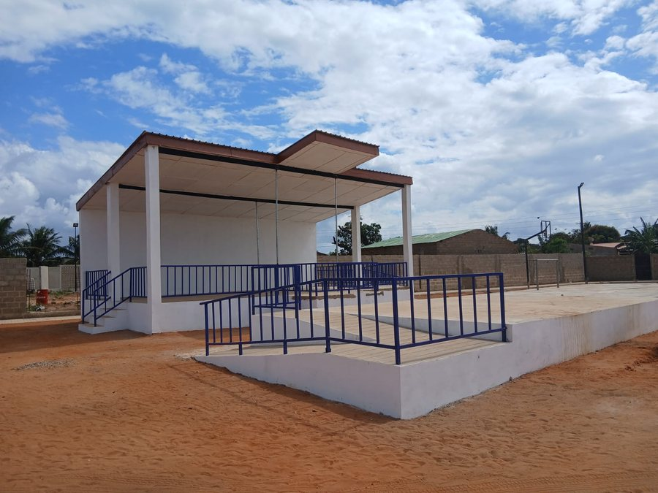 |  | 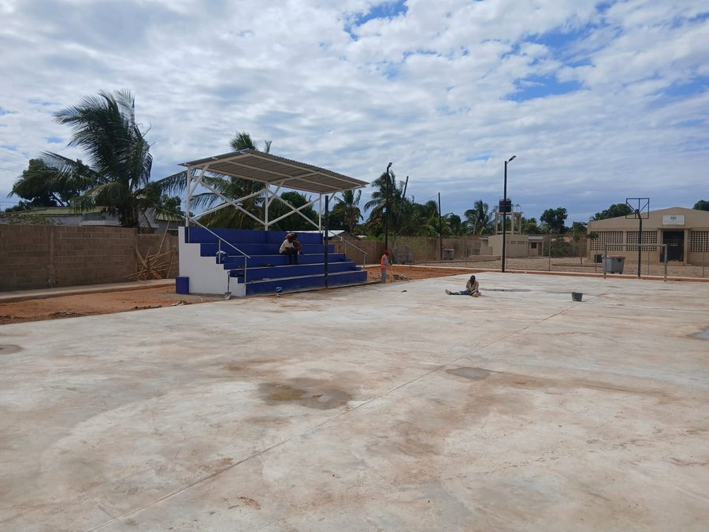
IMPACT
What the space will change
Open, public space is scarce in Pemba’s fast-growing neighbourhoods, and children in particular have few safe places to play. By creating one shared, well-lit and accessible space, the project gives families a reason to come together and gives children room to play, away from traffic and building sites.
For a neighbourhood shaped by displacement, a shared civic space also does quiet but important work: it brings displaced and host families onto common ground, supports local sport and events, and gives Muxara a place of its own. It is a small but real anchor for community identity and cohesion.

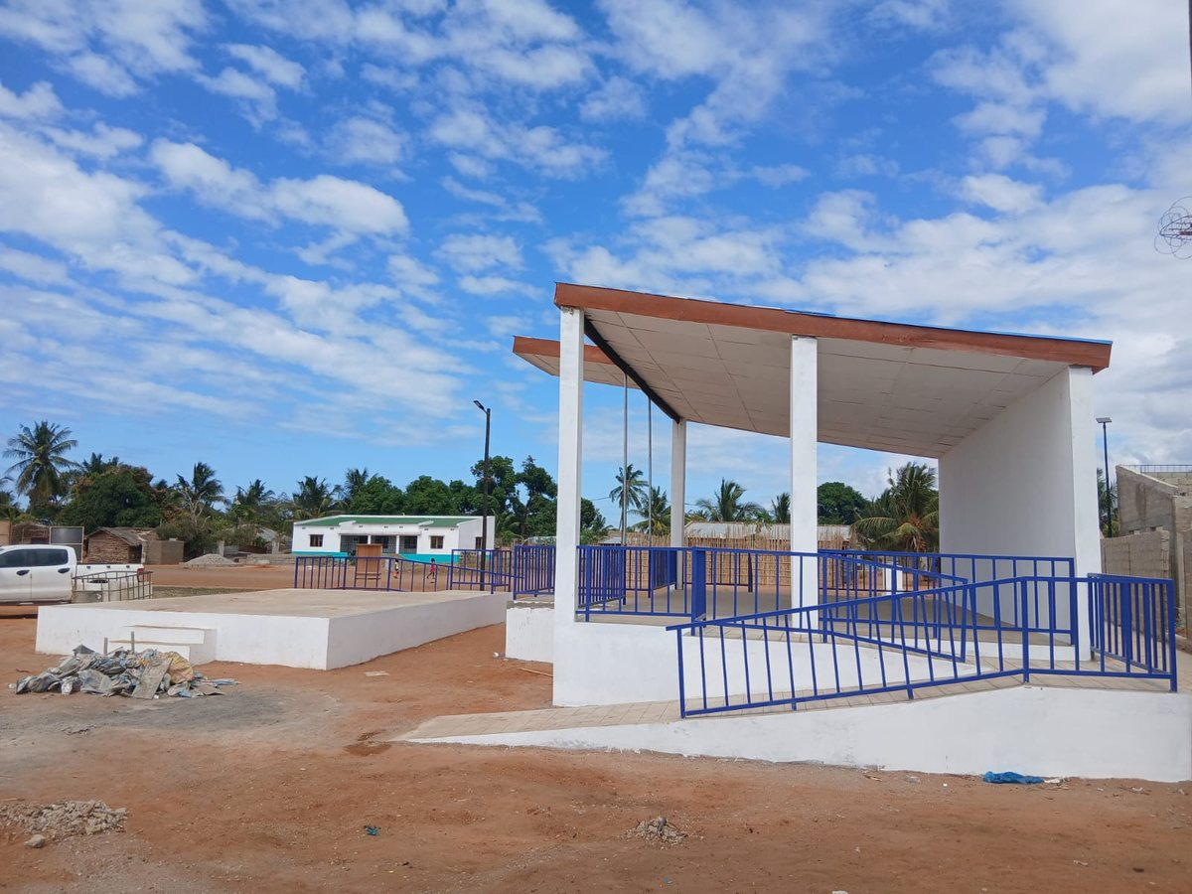
The finished pavilion and fields will give Muxara’s families and children a safe place to gather and play.
Contribution to social cohesion
Shared spaces where people meet as neighbours, at a match, at an event, or simply on a bench in the evening, build the everyday familiarity that underpins social cohesion. As people return and settle in Pemba, spaces like this help a mixed community become a single one.

HOW ALPS BUILDS
Built with the community, for the community
Construction is carried out directly through ALPS Constructions, ALPS Resilience’s licensed construction arm, using local labour drawn from the community being served. Involving residents in building their own space reinforces ownership of the result, and gives the neighbourhood a stake in looking after it.
The space was identified with the community and IOM as a local priority, so it answers a need residents named themselves rather than one set from outside. It is the participatory approach ALPS and IOM use to make sure infrastructure lands where it matters, and lasts.

CHALLENGES
Working through the constraints
Delivering quality infrastructure in Cabo Delgado comes with real constraints. Sourcing and transporting materials to Pemba adds cost and lead time, and prices for construction inputs can move quickly. Both have to be managed to keep the works on budget and on schedule.
On site, the sandy ground calls for careful groundworks and foundations, and rainy-season weather can interrupt concreting and slow the curing of the fields and other finishes. Coordinating a local labour force while holding to build quality and accessibility standards adds a further layer that ALPS’s site supervision is set up to manage.
RECOMMENDATIONS
Keeping the space working for the long term
To protect the investment and keep the space active, ALPS recommends putting community ownership and simple maintenance in place from the start.
Management committee  A local committee to oversee use, scheduling and day-to-day care. |  | Maintenance plan  Routine upkeep of lighting, paintwork and the fields, with a small local kit. |  | Active programming  Sport, events and activities that keep the space used and valued. |  | Equip & green  Sports equipment and shade planting to complete the space.

Pairing the eventual handover with a maintenance plan, and drawing on ALPS’s permanent presence in the province for periodic checks, gives the space the best chance of serving Muxara for years to come.

STATUS
Where the project stands
As of August 2026, the structures are complete and final works are underway on site. The space will be handed over to the community and local authorities in the coming weeks, once those final works are complete.
Aug 2026
structures complete and final works underway, community handover to follow in the coming weeks.

ABOUT ALPS RESILIENCE
Built by Mozambican teams, for Mozambican communities, to last.
ALPS Resilience delivers durable, community-prioritised infrastructure for regions of northern Mozambique recovering from conflict. The organisation has operated in Cabo Delgado since 2021, delivering water systems, police posts, schools and civic infrastructure under contracts from IOM, UNICEF, UNOPS, UNDP and others.
This report covers the Muxara public space, delivered for the International Organization for Migration.

OFFICE  Pemba |  | CONTACT  info@alpsresilience.com  www.alpsresilience.com

ALPS RESILIENCE
© 2026 ALPS Resilience. All rights reserved. In partnership with IOM Mozambique.

